PART 1: | GIFTS I'VE RECEIVED
Background: | "The Gift of the Magi" is a story about the true meaning of gift-giving. In this activity, you will reflect on some of the meaningful gifts you've received.
Directions:
Share information about some gifts you have received using the tables and ratings.
- In box 1, provide a brief title for the item.
- In box 2, provide a picture of the item (or a picture that represents the item). Be sure to resize the image so that it's not too big for the box!
- In box 3, provide a brief physical description of the item.
- In the boxes marked 4. rate the item on its monetary value and then on its sentimental value.
- In box 5, explain why the gift was important to you (which could be due to its monetary value, due to its sentimental value, or due to a combination of both) by answering the relevant questions provided.
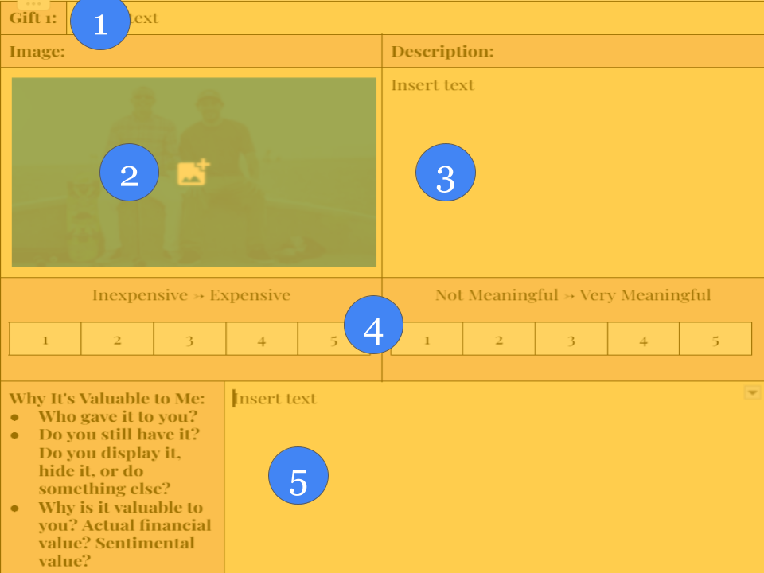

In box 2, replace the blank image by first clicking on it, and then using one of the two methods below:
Right-click on image > “Replace image” > “Search the web”
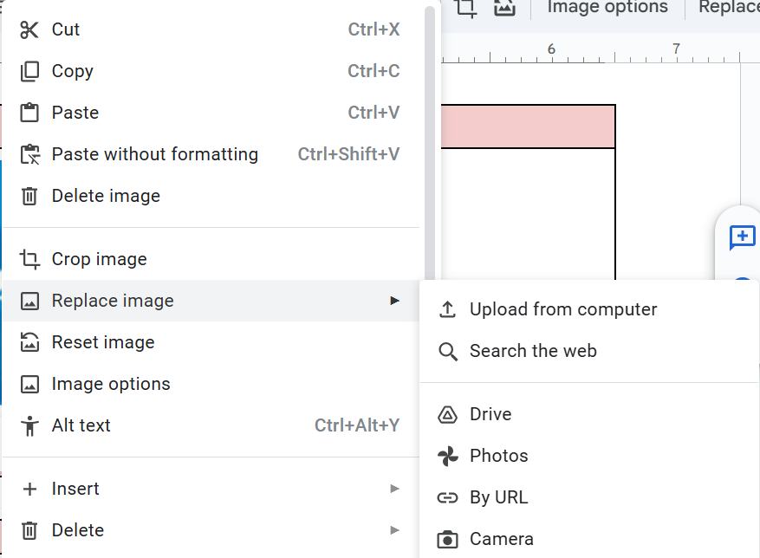
Select image > Click “Replace image” button > “Search the web”
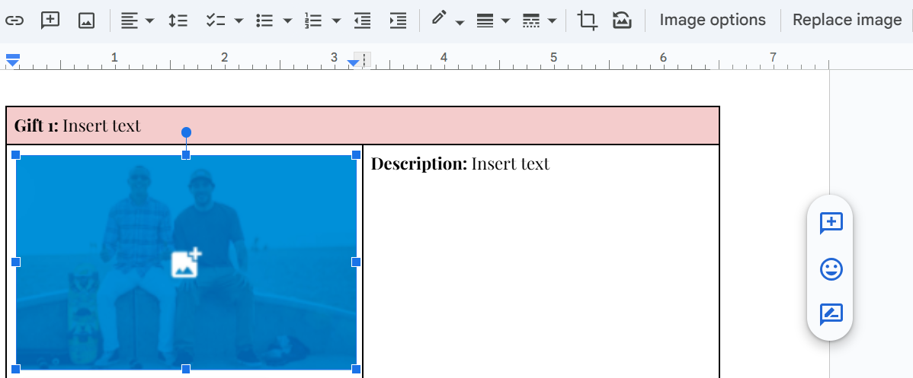

For both boxes marked 4, rate the item by first selecting the desired cell, and then clicking the hamburger symbol (three vertical dots), the paint bucket, and then “yellow” or another color that will stand out.
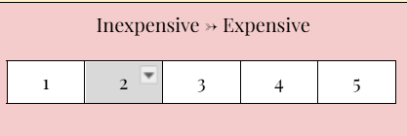 |  | 